Experiment to determine training speed and tflops used for training QLoRA vs LoRA in 1 unit of A100 gpu in Lanta. Control: model, data, optimizer, batchsize
different: Loading method of the model: Quantized model with bitsandbytes config vs loading model without bitsandbytes config

Reference: https://github.com/aws-samples/amazon-sagemaker-generativeai/blob/main/studio-notebook-fine-tuning/falcon-40b-qlora-finetune-summarize.ipynb

LoRA Tensorboard: https://colab.research.google.com/drive/1UFi3WgozGlP1OrswuIlCSbnBZRNdRXuy?usp=sharing
QLoRA Tensorboard: https://colab.research.google.com/drive/1kgXey6DsPeitXMa_ziGOKqdSCwZork9k?usp=sharing

Tflops LoRA: 1.98e+17
Tflops QLoRA 1.2e+17

time
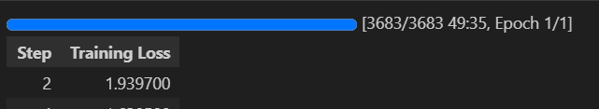
LoRA:

QLoRA:
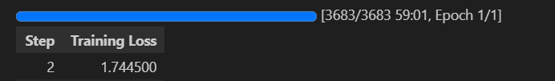
Observation: quantized peft model take longer time to be trained with the same setup than normal peft model

guess: Some bottleneck happen.

Need to study more about GPU profiling + away to record such thing into Tensorboard

